**周亚男 2020131062**

## 完善合约代码

04_Exchange.sol

// SPDX-License-Identifier: MIT

pragma solidity ^0.8.0;

import "@openzeppelin/contracts/token/ERC20/ERC20.sol";

import "@openzeppelin/contracts/token/ERC20/IERC20.sol";

interface IFactory {

    function getExchange(address tokenAddress) external returns (address);

}

contract Exchange is ERC20 {

    address public tokenAddress;

    address public usdtAddress;

    address public factoryAddress;

    // events

    event TokenPurchase(

        address indexed buyer,

        uint256 indexed usdtSold,

        uint256 tokenBought

    );

    event UsdtPurchase(

        address indexed buyer,

        uint256 indexed tokenSold,

        uint256 usdtBought

    );

    event AddLiquidity(

        address indexed provider,

        uint256 indexed usdtAmount,

        uint256 indexed tokenAmount

    );

    event RemoveLiquidity(

        address indexed provider,

        uint256 indexed usdtAmount,

        uint256 indexed tokenAmount

    );

    constructor(address token, address usdt) ERC20("cbiswap", "CBI") {

        require(token != address(0), "invalid token address");

        tokenAddress = token;

        usdtAddress = usdt;

        factoryAddress = msg.sender;

    }

    function addLiquidity(

        uint256 tokenAmount,

        uint256 usdtAmount

    ) public returns (uint256 liquidity) {

        // Retrieve reserves

        (uint256 tokenReserve, uint256 usdtReserve) = getReserves();

        if (tokenReserve == 0) {

            IERC20(tokenAddress).transferFrom(

                msg.sender,

                address(this),

                tokenAmount

            );

            IERC20(usdtAddress).transferFrom(

                msg.sender,

                address(this),

                usdtAmount

            );

            liquidity = _sqrt(tokenAmount * usdtAmount);

        } else {

            // 这一步是干啥的

            usdtReserve =

                usdtReserve -

                IERC20(usdtAddress).balanceOf(address(this));

            uint256 expectedTokenAmount = (IERC20(usdtAddress).balanceOf(

                address(this)

            ) * tokenReserve) / usdtReserve;

            require(

                tokenAmount >= expectedTokenAmount,

                "Insufficient token amount"

            );

            IERC20(tokenAddress).transferFrom(

                msg.sender,

                address(this),

                expectedTokenAmount

            );

            IERC20(usdtAddress).transferFrom(

                msg.sender,

                address(this),

                usdtAmount

            );

            liquidity =

                (totalSupply() * IERC20(usdtAddress).balanceOf(address(this))) /

                usdtReserve;

        }

        _mint(msg.sender, liquidity);

        // 这里是不是错了:tokenAmount => expectedTokenAmount

        // 或者是应该放在函数里

        emit AddLiquidity(msg.sender, usdtAmount, tokenAmount);

    }

    function removeLiquidity(

        uint256 liquidity

    ) public returns (uint256 usdtAmount, uint256 tokenAmount) {

        require(liquidity > 0, "Amount of liquidity cannot be 0");

        // 判断流动性是否足够

        require(balanceOf(msg.sender) >= liquidity);

        // Retrieve reserves

        (uint256 tokenReserve, uint256 usdtReserve) = getReserves();

        // calculate the amount of Token & USDT based on the ratio

        usdtAmount = (usdtReserve * liquidity) / totalSupply();

        tokenAmount = (tokenReserve * liquidity) / totalSupply();

        // reduce supply of liquidities

        _burn(msg.sender, liquidity);

        // returns USDT & Token to the liquidity provider

        IERC20(usdtAddress).transfer(msg.sender, usdtAmount);

        IERC20(tokenAddress).transfer(msg.sender, tokenAmount);

        emit RemoveLiquidity(msg.sender, usdtAmount, tokenAmount);

    }

    // 使用特定数量的USDT购买Token

    function swapExactUsdtToToken(

        uint256 amountUsdtIn,

        // 这个变量的实际意义是什么

        uint256 expectedTokenAmount,

        address to

    ) public {

        // 补全

        require(amountUsdtIn > 0);

        uint256 amountTokenOut = getAmountOut(amountUsdtIn, usdtAddress);

        require(expectedTokenAmount <= amountTokenOut);

        IERC20(usdtAddress).transferFrom(

            msg.sender,

            address(this),

            amountUsdtIn

        );

        IERC20(tokenAddress).transfer(to, amountTokenOut);

        emit TokenPurchase(to, amountUsdtIn, amountTokenOut);

    }

    // 使用USDT购买特定数量的Token

    function swapUsdtToExactToken(

        uint256 amountTokenOut,

        uint256 maxUsdtAmountIn,

        address to

    ) public {

        // 补全

        require(amountTokenOut > 0);

        uint256 amountUsdtIn = getAmountIn(amountTokenOut, tokenAddress);

        require(maxUsdtAmountIn >= amountUsdtIn);

        IERC20(usdtAddress).transferFrom(

            msg.sender,

            address(this),

            amountUsdtIn

        );

        IERC20(tokenAddress).transfer(to, amountTokenOut);

        emit TokenPurchase(to, amountUsdtIn, amountTokenOut);

    }

    // 使用特定数量的Token购买USDT

    function swapExactTokenToUsdt(

        uint256 amountTokenIn,

        uint256 expectedUsdtAmount,

        address to

    ) public {

        // 补全

        require(amountTokenIn > 0);

        uint256 amountUsdtOut = getAmountOut(amountTokenIn, tokenAddress);

        require(expectedUsdtAmount <= amountUsdtOut);

        IERC20(tokenAddress).transferFrom(

            msg.sender,

            address(this),

            amountTokenIn

        );

        IERC20(usdtAddress).transfer(to, amountUsdtOut);

        emit UsdtPurchase(to, amountUsdtOut, amountTokenIn);

    }

    // 使用Token购买特定数量的USDT

    function swapTokenToExactUsdt(

        uint256 amountUsdtOut,

        uint256 maxTokenAmountIn,

        address to

    ) public {

        // 补全

        require(amountUsdtOut > 0);

        uint256 amountTokenIn = getAmountIn(amountUsdtOut, usdtAddress);

        require(maxTokenAmountIn >= amountTokenIn);

        IERC20(tokenAddress).transferFrom(

            msg.sender,

            address(this),

            amountTokenIn

        );

        IERC20(usdtAddress).transfer(to, amountUsdtOut);

        emit UsdtPurchase(to, amountUsdtOut, amountTokenIn);

    }

    function getReserves()

        public

        view

        returns (uint256 tokenReserve, uint256 usdtReserve)

    {

        tokenReserve = IERC20(tokenAddress).balanceOf(address(this));

        usdtReserve = IERC20(usdtAddress).balanceOf(address(this));

    }

    // 已知确定的输入数量和币种，计算输出数量

    function getAmountOut(

        uint256 inputAmount,

        address inputToken

    ) public view returns (uint256 outputAmount) {

        // 补全

        require(inputAmount > 0);

        require(inputToken == usdtAddress || inputToken == tokenAddress);

        (uint256 tokenReserve, uint256 usdtReserve) = getReserves();

        if (inputToken == usdtAddress) {

            outputAmount =

                tokenReserve -

                (usdtReserve * tokenReserve) /

                (usdtReserve + inputAmount);

        } else {

            outputAmount =

                usdtReserve -

                (usdtReserve * tokenReserve) /

                (tokenReserve + inputAmount);

        }

    }

    // 已知确定的输出数量和币种，计算输入数量

    function getAmountIn(

        uint256 outputAmount,

        address outputToken

    ) public view returns (uint256 inputAmount) {

        // 补全

        require(outputAmount > 0, "not enough");

        require(outputToken == usdtAddress || outputToken == tokenAddress);

        (uint256 tokenReserve, uint256 usdtReserve) = getReserves();

        if (outputToken == usdtAddress) {

            inputAmount =

                (usdtReserve * tokenReserve) /

                (usdtReserve - outputAmount) -

                tokenReserve;

        } else {

            inputAmount =

                (usdtReserve * tokenReserve) /

                (tokenReserve - outputAmount) -

                usdtReserve;

        }

    }

    function _sqrt(uint y) private pure returns (uint z) {

        if (y > 3) {

            z = y;

            uint x = y / 2 + 1;

            while (x < z) {

                z = x;

                x = (y / x + x) / 2;

            }

        } else if (y != 0) {

            z = 1;

        }

    }

}

## 实验过程

1. 仔细阅读 Factory.sol 合约，思考它与 Exchange.sol 的关系  
   factory合约记录哪些token和usdt可以交换，创建交易对  
   exchange合约是专实现交换功能的合约
2. 部署合约  
   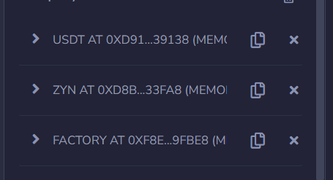
3. 调用 factory 的 createExchange 方法，创建自己名字命名的币的交易对  
   查询交易对的地址  
   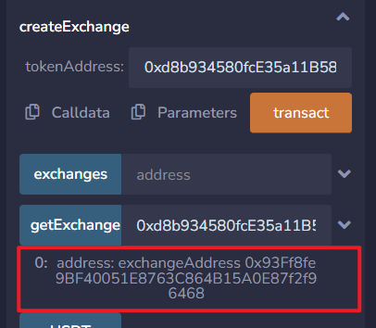
4. 引入交易对  
   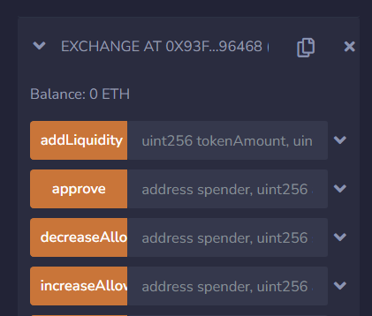
5. 添加流动性，每边 10000 个 token  
   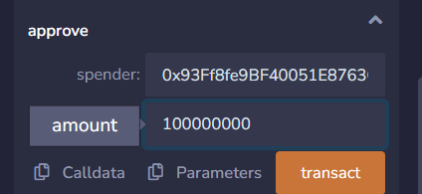  
     
   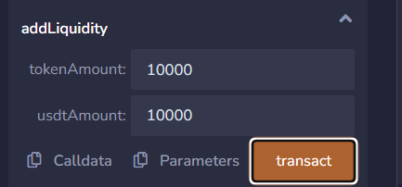
6. 查看 totalSupply  
   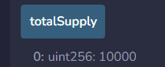
7. 调用 swapExactTokenToUsdt  
   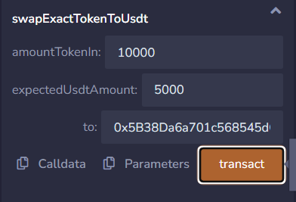
8. 查看 getReserves  
   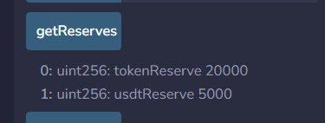
9. 调用 swapExactUsdtToToken  
   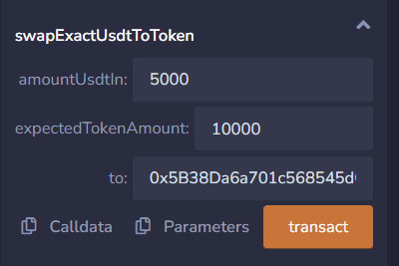
10. 查看 getReserves  
    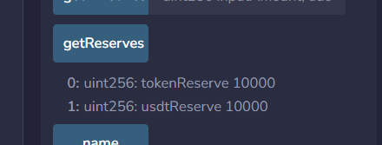
11. 调用 swapTokenToExactUsdt  
    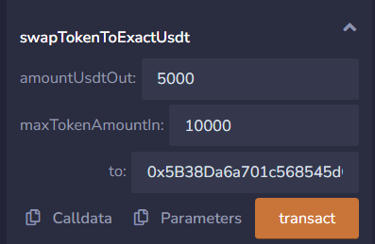
12. 查看 getReserves  
    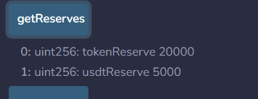
13. 调用 swapUsdtToExactToken  
    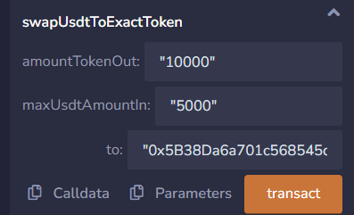
14. 查看 getReserves  
    